CS 148 Section B

Samuel Reinhardt, Michael Cardoso, Andrew Driscoll

Final Project

UVM Bounty Board

Table Of Contents

Time Log 3

Introduction 4

Purpose 4

Definitions, acronyms, and abbreviations 4

Overall Description 4

Story Board 5

Specific requirements 6

|  |  |  |  |
| --- | --- | --- | --- |
| Time Log | | | |
| Estimated time to complete assignment => | | | 30 Hours |
| Date | Time Spent  (in hours) | Description | Author |
| 11/13 | .25 | Initial index creation | Sam R. |
| 11/19 | 1 | Added page files, erd, modified database class | Sam R. |
| 11/19 | .25 | Modified erd. | Andrew D. |
| 11/24 | .25 | Updated read me | Mike C. |
| 11/30 | .25 | Updated read me | Andrew D. |
| 11/30 | 1 | Added nav, styling, more sql items, record insertions | Sam R. |
| 12/2 | 3 | Compartmentalizing, updating form, manage, profile, item, style and parts of pages | Sam R. |
| 12/3 | 1 | Database submission | Sam R. |
| 12/4 | 1 | Form submission | Sam R. Andrew D. |
| 12/4 | .5 | countCode array work | Sam R. |
| 12/5 | .25 | Removed url | Mike C. |
| 12/5 | 1 | Edit function | Mike C. |
| 12/5 | 1 | Authentication for edit | Mike C. |
| 12/5 | .5 | Autofill form from update.php and database | Mike C. |
| 12/6 | 2 | Styling overhauling | Sam R. |
| 12/6 | .5 | Email on submission | Andrew D. |
| 12/6 | 1 | Alert work | Sam R. |
| 12/6 | .5 | Manage.php edit, styling work | Mike C. |
| 12/7 | .5 | Modified erd | Andrew D. |
| 12/7 | .5 | Header, tab edit | Andrew D. |
| 12/7 | .5 | Fixed image not showing up for users | Sam R. |
|  | 16.25 | <=Total Time Spent |  |
|  |  |  |  |

# Introduction

### Purpose

The purpose of this document is to describe the requirement specification for the web site UVM Bounty Board.

The intended audience for this document is UVM Students.

*First it is the contract between you and the client. Second it is for the developer of the site. Two primary goals are:*

1. *Client gets a very good understanding of what you will be delivering.*
2. *Developer has a very good understanding of what they are going to create.*

### Definitions, acronyms, and abbreviations

*Sample for the client:*

HTML – Hypertext markup language – used to define your content.

PHP – Personal Home Page – language that helps to customize html.

CSS – Cascading Style Sheets – used to define the look of a web site.

W3 Validation – refers to both Html and CSS validation tool provided by the W3c.org. the html validator is located at:

<http://validator.w3.org/>

with the CSS validator located at:

<http://jigsaw.w3.org/css-validator/>

# Overall Description

A short paragraph describing the site

The UVM Bounty Board is an accessible way for students to report lost or found personal belongings on campus. Students can submit an item, lost or found, and keep track of their items they’ve submitted by viewing their profile on the site. Students can also set an alert for themselves on the site

# 

# Entity Relationship Diagram

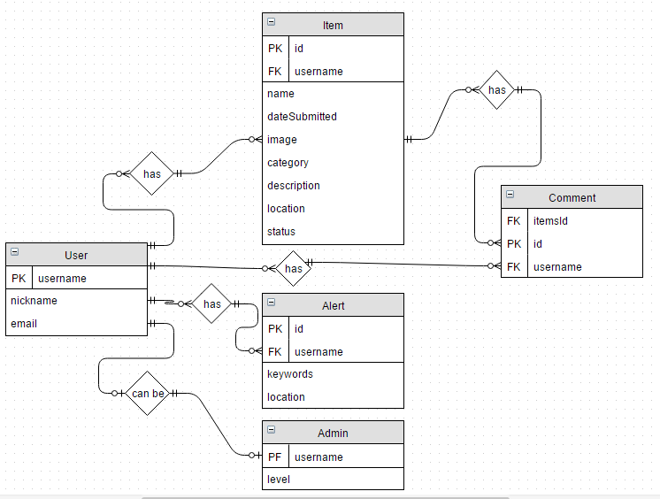

# Specific requirements

1. *You fill out* – This is where you would put the exact detail of what you want for the project. For example:
2. *Title for main page*: UVM Bounty Board
3. *Meta Description*: Homework assignment 10 for CS148
4. *Meta Character set*: UTF - 8
5. *Content can be found here*: <https://afdrisco.w3.uvm.edu/cs148/assignment10/>

<https://swreinha.w3.uvm.edu/cs148/assignment10/>

<https://mcardoso.w3.uvm.edu/cs148/assignment10/>